Plebeian Deputy Editor-in-Chief Application
Thank you for showing interest in joining the Plebeian Editorial Board! The application process has two steps—submission of your completed Application and, for those applications selected, an Interview. The Application includes:
- This filled out Application Form
- A writing sample of 1500-2500 words, attached as a Word Document with the title “firstname.lastname.2018” (e.g. Bob Cicero’s would be: bob.cicero.2018)
Here is a summary of the responsibilities and the roles of the Editorial Board that require an application and interview. For the full listing and details of the process, please visit our website. Note that Peak Hours refers to the selection and editing rounds in January through March.
Position | Editor-in-Chief | Deputy Editor | Associate Editors
Application Period | March (Now Closed) | September | October
Number of Positions | 1 | 1 | 7
Peak Hours per week | 4 | 2-3 | 1-2
Responsibilities | - Oversight over the entire publication process of Plebeian  - Setting timelines for editor applications, paper submissions, and drafts  - Hiring Editors and running meetings with the Editing Team  - Reading and ranking of all paper submissions  - Checking over the quality of edits made by individual editing pairs to ensure proper quality  - Settling disputes, and, if necessary appointing replacements  - Design, layout, and formatting of the journal  - Delivery of the final product to the Senate  - Copy editing  - Promoting and advertising the calls for papers and editors in conjunction with the Senate | - Serving as the second-in-command, backup Chief  - Advise on design, deadlines, and meetings  - Hiring Associate Editors, and assisting with replacements  - Reading and ranking of all paper submissions  - Giving input on editorial decisions presented to the Editing Team  - Editing two papers with a partnered Editing Team member  - Observing deadlines for returning drafts to Submitters  - Meeting with the authors of the two assigned papers at least once | - Reading and ranking of all paper submissions  - Giving input on editorial decisions presented to the Editing Team  - Editing two papers with a partnered Editing Team member  - Observing deadlines for returning drafts to Submitters  - Meeting with the authors of the two assigned papers at least once

Please fill in the form below and submit the entire package to classu.plebeian@gmail.com by OCTOBER 9th 2018. If you have any questions, concerns, or issues, please send us an email.
You will be contacted within ten days of the deadline with the result. Thanks for applying!
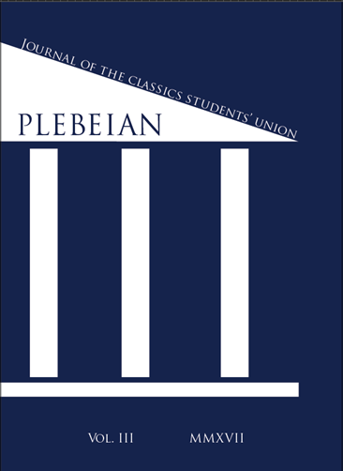 | Plebeian Editorial Board Application
 | This is the application form to apply to be a hired member of the Plebeian Editorial Board. Please review the responsibilities and commitments of the position for which you are applying. Please send this completed form, your CV, and writing sample to classu.plebeian@gmail.com by OCTOBER 9th 2018.
 | Name:
 | Student Nº:
 | Telephone Nº:
 | Year: (Circle)
 | Email:
 | College:
 | Subject POSts:
 | Position:

1. Please list all the Classics courses you have taken (### separated with commas, e.g. 160, 260, etc.).
 | Group | Course Codes
a) | Classical Civilization Courses | CLA
b) | Greek Courses | GRK
c) | Latin Courses | LAT
d) | Other Relevant Courses

2. Please list any relevant editorial experiences and academic achievements. Add rows as necessary.
Date (Month/Year) | Organization | Experience/Achievement and Description

3. Please list your co-curricular and/or work commitments for the academic year. Add rows as necessary.
Organization | Position

4. What experience or skills make you an ideal candidate for membership on the Editorial Board? Include new ideas you can bring to your position and to Plebeian in general. Please enter no more than 100 words.

Thank you for applying to the Editorial Board of Plebeian.

