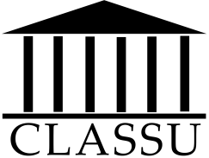
Undergraduate Conference on the Classical World
Hosted by the Classics Students’ Union
Now calling for submissions for our conference and journal!
Call for Papers
We are looking for papers to be presented at our conference on March 15th, 2019. Papers presented at the conference will be published in volume V of our journal, Plebeian.
Any student registered in the Faculty of Arts and Science in the 2018-2019 academic year is eligible to submit a paper; the paper, however, may have been written before this current term.
The paper must have a maximum word count of 5,000 and be related in some way to the Classical world. We strongly encourage you to consider submitting papers that received A-range grades in 300- and 400-level courses and independent studies, although any and all papers we receive will be considered.
Papers can be sent to us by email, at classu.plebeian@gmail.com. The deadline for submissions is January 18th, 2019. Once the deadline has passed, we will select up to eight papers for presentation at the conference and publication in Plebeian. Authors will be notified within a week.
Submitters must be available throughout the spring term for edits, and must be available on March 15th, 2019.
E-mail your papers to:
classu.plebeian@gmail.com
The deadline for submissions is: January 18th, 2019

